ZABBIX-RUNDECK

Lab-Guide

**www.zippyops.com**

209/210, 1st floor, J Nagar

Panaiyur Kuppam Road,

Panaiyur, Chennai-600119

****[**zippyops@gmail.com**](mailto:zippyops@gmail.com)

**+91 7010585768**

Project Name: WEB RESPONSE TIME

# Overview

In this project we are going to monitor the RESPONSE TIME ON WEBSITE in Linux and Windows machines by using Zabbix and Zabbix-agent. The Zabbix will trigger the rundeck Job when the Response Time is High. Then the Inline Script in rundeck job will restart service related to it.

# 1.ZABBIX:

## 1.Add HOST in zabbix server like this:

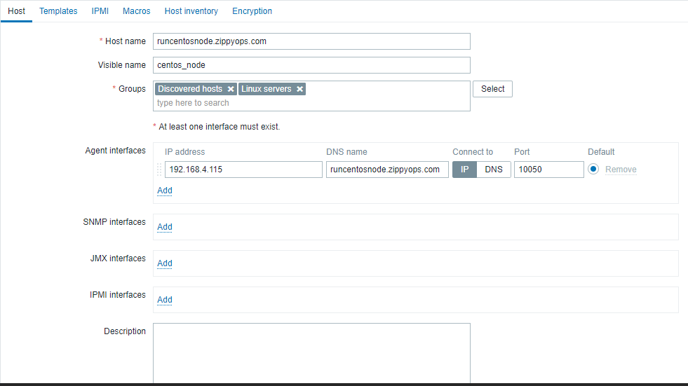

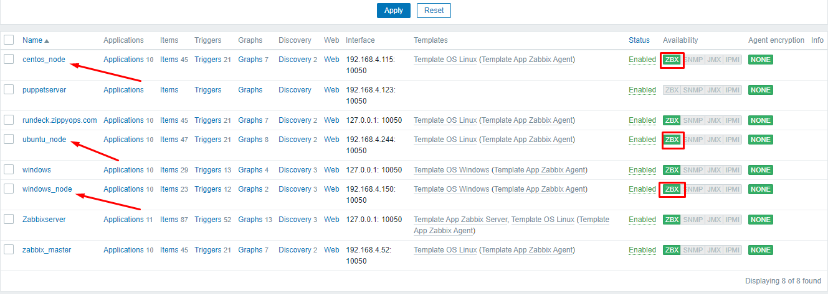

## 2. Create a Trigger for Response Time:(Centos,Ubuntu & Windows).

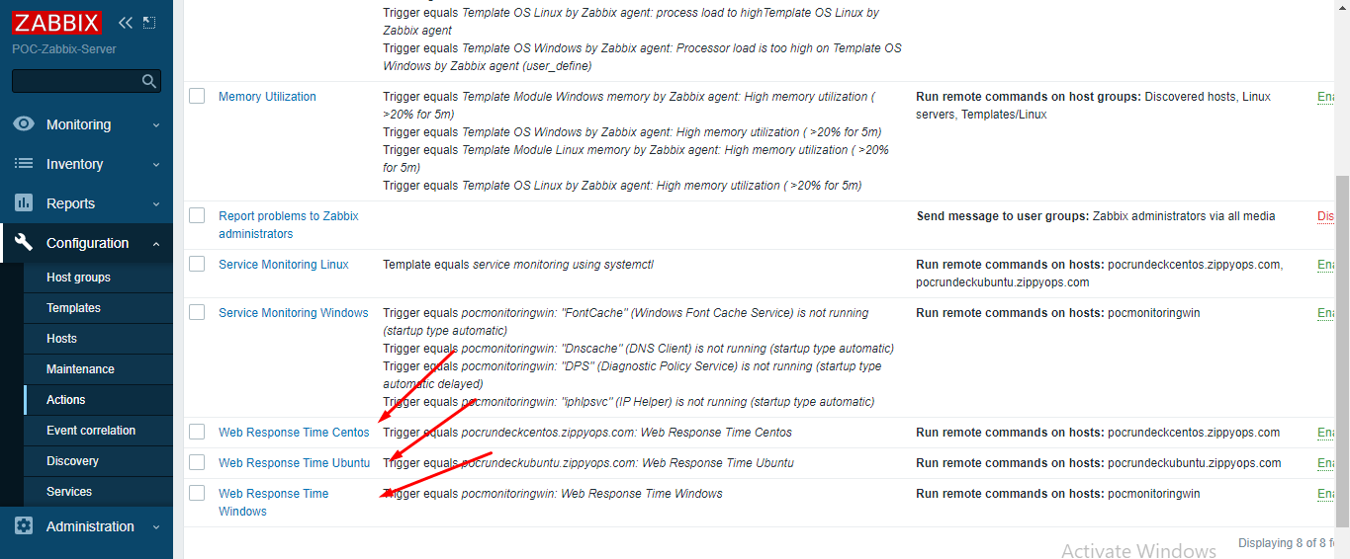

## 3 Create an Action for Web Response Time and add condition.

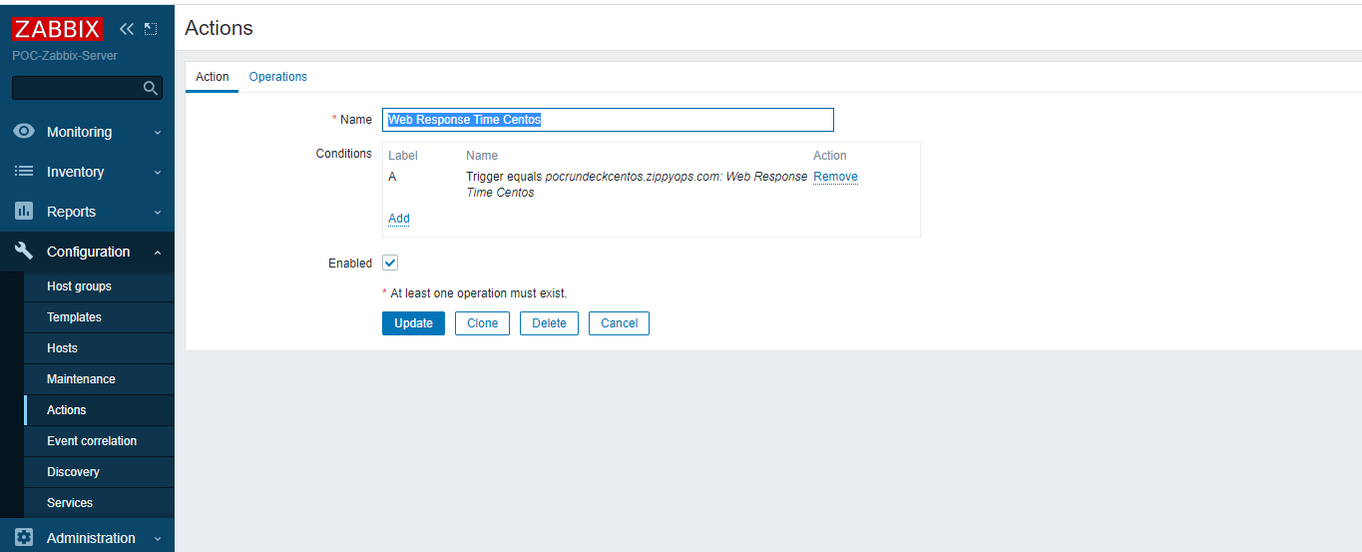

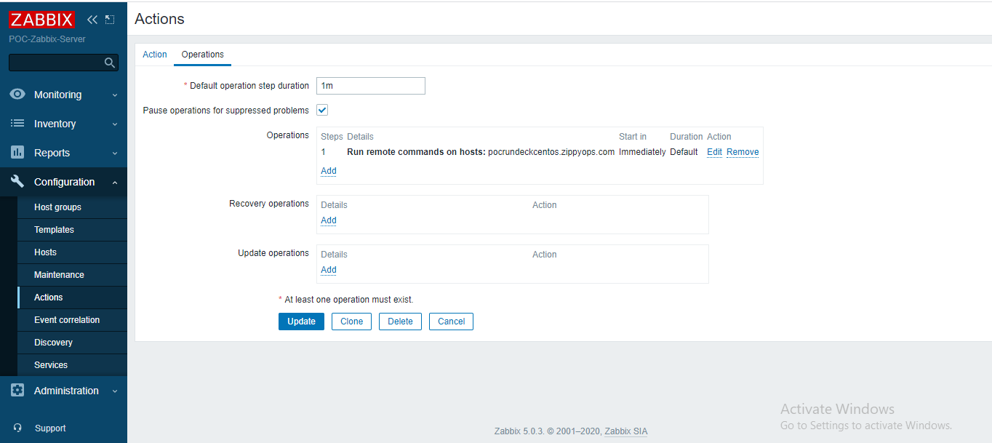

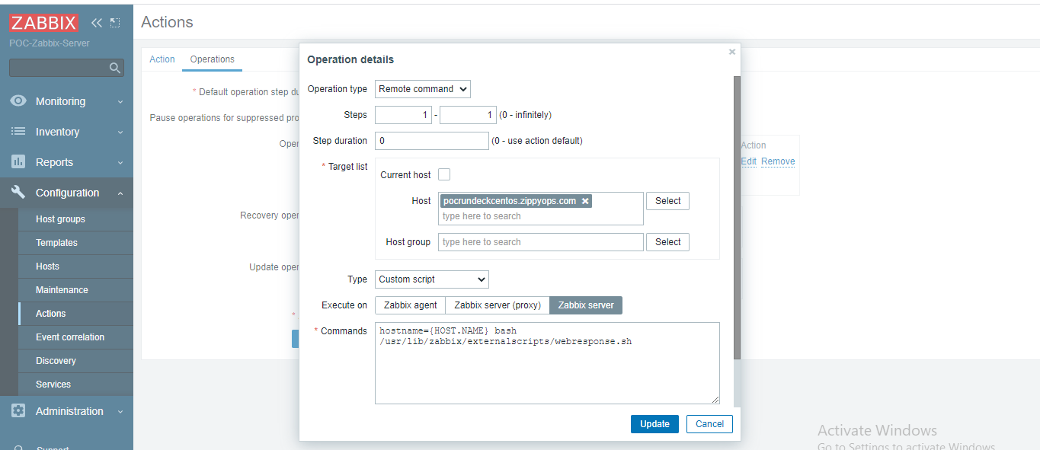

Same operation settings for Linux by selecting linux hosts in Host column.

# 2.RUNDECK:

## 1. Create a Project for Web Response Time:(Linux & Windows).

### **LINUX:**

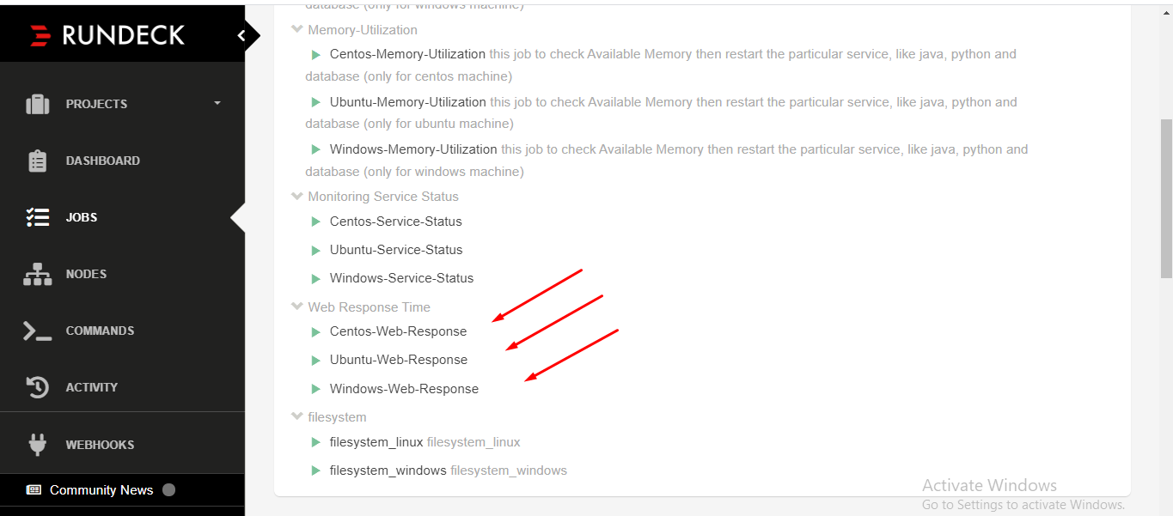

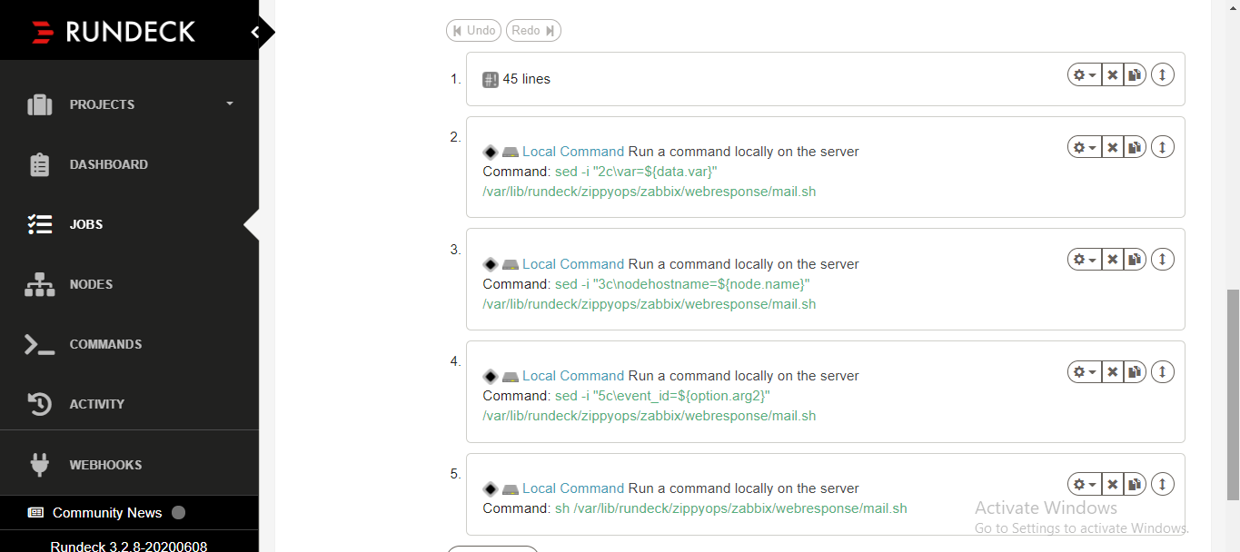

### **WINDOWS:**

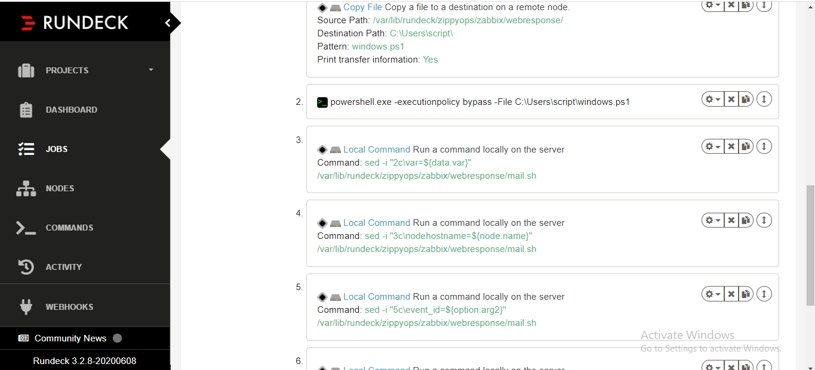

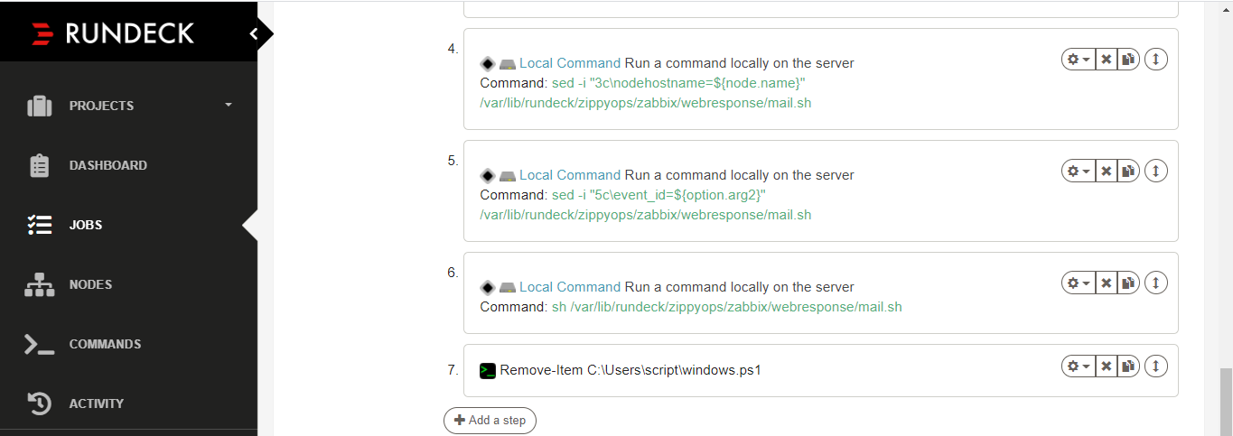

## LINUX SCRIPT:

**nodeostype=@node.os-name@**

**HOSTNAME=@option.arg1@**

**SERVICENAME=@option.arg2@**

**echo "$nodeostype"**

**echo "$HOSTNAME"**

**echo "$SERVICENAME"**

**if [ "$nodeostype" == "centos" ]; then**

**echo "This is linux machine 192.168.4.115"**

**if [ "$SERVICENAME" = "sshd" ]**

**then**

**systemctl restart sshd**

**var="$SERVICENAME"**

**echo "$var"**

**sleep 5**

**echo "this is $SERVICE"**

**elif [ "$SERVICENAME" != "192.168.4.115/demo.php" ]**

**then**

**systemctl restart httpd.service**

**var=httpd**

**echo "$var"**

**sleep 5**

**elif [ "$SERVICENAME" = "mysqld" ]**

**then**

**systemctl restart mariadb**

**var="$SERVICENAME"**

**echo "$var"**

**echo "this is $SERVICENAME"**

**sleep 5**

**elif [ "$SERVICENAME" = "crond" ]**

**then**

**systemctl restart crond**

**var="$SERVICENAME"**

**echo "$var"**

**echo "this is $SERVICENAME"**

**sleep 5**

**else**

**echo "not for this"**

**var="$SERVICENAME"**

**echo "$var"**

**echo "this is $SERVICENAME"**

**fi**

**fi**

**echo "var=$var"**

## WINDOWS SCRIPT:

**$URL = 'http://192.168.4.22/demo.php'**

**$TimeTaken = Measure-Command -Expression {**

**$Site = Invoke-WebRequest -Uri $URL**

**}**

**$Seconds = [Math]::Round($TimeTaken.TotalSeconds)**

**Write-Output("$Seconds")**

**if(($Seconds -ge 1) -and ($URL -eq 'http://192.168.4.22/demo.php')){**

**Restart-Service -Name apache**

**Write-Output("$URL")**

**} elseif(($Seconds -ge 1) -and ($URL -eq 'http://192.168.4.115:80')){**

**Restart-Service -Name apache**

**Write-Output("$URL")**

**} else {**

**Write-Output("BYE")**

**}**

## MAIL SCRIPT:

**#!/bin/bash**

**var=apache2**

**nodehostname=ubuntunode**

**mail=alerts@zippyops.in**

**event_id=**

**if [ $nodehostname == centosnode ]; then**

**if [ "$var" == "crond" ]; then**

**echo "$var Service Restarted on $nodehostname" | mail -s "Web Response Time High on Centos node" $mail**

**elif [ "$var" == "httpd" ]; then**

**echo "$var Service Restarted on $nodehostname" | mail -s "Web Response Time High on Centos node" $mail**

**elif [ "$var" == "ssh" ]; then**

**echo "$var Service Restarted on $nodehostname" | mail -s "Web Response Time High on Centos node" $mail**

**elif [ "$var" == "$var" ]; then**

**echo "$var Service Restarted on $nodehostname" | mail -s "Web Response Time High on Centos node" $mail**

**else**

**echo "this is not $nodehostname"**

**exit 0**

**fi**

**elif [ $nodehostname == ubuntunode ]; then**

**if [ "$var" == "cron" ]; then**

**echo "$var Service Restarted on $nodehostname" | mail -s "Web Response Time High on Ubuntu node" $mail**

**elif [ "$var" == "java" ]; then**

**echo "$var Service Restarted on $nodehostname" | mail -s "Web Response Time High on Ubuntu node" $mail**

**elif [ "$var" == "apache2" ]; then**

**echo "$var Service Restarted on $nodehostname" | mail -s "Web Response Time High on Ubuntu node" $mail**

**elif [ "$var" == "$var" ]; then**

**echo "$var Service Restarted on $nodehostname" | mail -s "Web Response Time High on Ubuntu node" $mail**

**else**

**echo "this is not $nodehostname"**

**exit 0**

**fi**

**elif [ $nodehostname == windowsnode ]; then**

**if [ "$var" == "System" ]; then**

**echo "$var Service Restarted on $nodehostname" | mail -s "Web Response Time High on Windows node" $mail**

**elif [ "$var" == "httpd" ]; then**

**echo "$var Service Restarted on $nodehostname" | mail -s "Web Response Time High on Windows node" $mail**

**elif [ "$var" == "python" ]; then**

**echo "$var Service Restarted on $nodehostname" | mail -s "Web Response Time High on Windows node" $mail**

**elif [ "$var" == "$var" ]; then**

**echo "$var Service Restarted on $nodehostname" | mail -s "Web Response Time High on Windows node" $mail**

**else**

**echo "this is not $nodehostname"**

**exit 0**

**fi**

**fi**

**[root@pocrundeck ~]#**

**[root@pocrundeck ~]# vi /var/lib/rundeck/zippyops/zabbix/webresponse/mail.sh**

**echo "$var Service Restarted on $nodehostname" | mail -s "Web Response Time High on Ubuntu node" $mail**

**elif [ "$var" == "apache2" ]; then**

**echo "$var Service Restarted on $nodehostname" | mail -s "Web Response Time High on Ubuntu node" $mail**

**elif [ "$var" == "$var" ]; then**

**echo "$var Service Restarted on $nodehostname" | mail -s "Web Response Time High on Ubuntu node" $mail**

**else**

**echo "this is not $nodehostname"**

**exit 0**

**fi**

**elif [ $nodehostname == windowsnode ]; then**

**if [ "$var" == "System" ]; then**

**echo "$var Service Restarted on $nodehostname" | mail -s "Web Response Time High on Windows node" $mail**

**elif [ "$var" == "httpd" ]; then**

**echo "$var Service Restarted on $nodehostname" | mail -s "Web Response Time High on Windows node" $mail**

**elif [ "$var" == "python" ]; then**

**echo "$var Service Restarted on $nodehostname" | mail -s "Web Response Time High on Windows node" $mail**

**elif [ "$var" == "$var" ]; then**

**echo "$var Service Restarted on $nodehostname" | mail -s "Web Response Time High on Windows node" $mail**

**else**

**echo "this is not $nodehostname"**

**exit 0**

**fi**

**fi**